Software Architecture Document
AXIS

CONFIDENTIAL
27 pages

Change History
Version | Date | Status | Change description | Author/Editor
0.1 | 1 Nov 2011 | draft | initial | Dmitry Lobashevsky
0.2 | 18 Nov 2011 | Draft | - Updates to correct English grammar and word usage  - Updates to formatting for readability  - Add missing acronym definitions  - Add captions to figures  - See also the comment on the glossary and acronym list  - See also comment for empty sections:  - 1.8 Significant Driving Requirements  - 2.1.1 View Description  - 2.1.1.1 Global View | Pamela Traphagen
0.3 | 04 Dec 2011 | Draft | Document rework | Mikhail Prosuntsov
Table of Contents
1. Change History 2
2. Purpose 4
3. Product overview 5
3.1. Problem Statement 5
3.2. Solution 5
3.3. Use-cases 6
3.4. Features and Requirements 6
3.4.1. Supported platforms: 6
3.4.2. Connection between devices: 6
3.4.3. Programming with AXIS technology 7
4. Architecture Overview 8
4.1. Application layer (L4) 8
4.2. Service layer (L3) 8
4.3. Profile layer (L2) 8
4.4. Data transfer layer (L1) 9
4.5. Carrier abstraction layer (L0) 9
5. AXIS SDK 10
5.1. Concept and characteristics 10
5.1.1. Concept 10
5.1.2. Operation 10
5.2. Reference (API description) 10
5.3. OEM-Developed Components 10
5.4. Community-Developed Components 10
5.5. Programming Languages 10
Approve History 11
6. References 12
Appendix A - Acronym List 13
Appendix B - Glossary 14

Purpose
This Software architecture document describes overall architecture of the Accessory Control and Connectivity for Infotainment Systems (AXIS), the technology for seamless, multimodal data exchange between automotive, mobile and home infotainment devices.
The specification also lists basic use-cases, application and description of used technologies.

The key words "MUST", "MUST NOT", "REQUIRED", "SHALL", "SHALL NOT", "SHOULD", "SHOULD NOT", "RECOMMENDED", "MAY", and "OPTIONAL" in this document are following the notation as described in RFC 2119 [13].
1. MUST: This word, or the terms "REQUIRED" or "SHALL", mean that the definition is an absolute requirement of the specification.
2. MUST NOT: This phrase, or the phrase "SHALL NOT", mean that the definition is an absolute prohibition of the specification.
3. SHOULD: This word, or the adjective "RECOMMENDED", mean that there may exist valid reasons in particular circumstances to ignore a particular item, but the full implications must be understood and carefully weighed before choosing a different course.
4. SHOULD NOT: This phrase, or the phrase "NOT RECOMMENDED" mean that there may exist valid reasons in particular circumstances when the particular behavior is acceptable or even useful, but the full implications should be understood and the case care-fully weighed before implementing any behavior described with this label.
5. MAY: This word, or the adjective "OPTIONAL", means that an item is truly optional. One vendor may choose to include the item because a particular marketplace requires it or because the vendor feels that it enhances the product while another vendor may omit the same item. An implementation which does not include a particular option MUST be prepared to interoperate with another implementation which does include the option, though perhaps with reduced functionality. In the same vein an implementation which does include a particular option MUST be prepared to interoperate with another implementation which does not include the option (except, of course, for the feature the option provides.)

The document does not provide any protocols and profiles specification, any guidelines for implementation of the applications based on AXIS SDK.

Product overview

Problem Statement
With the current level of automotive infotainment usage, portable user electronics such as mobile phones and tablet PCs have an important value-added opportunity to be used as both terminal HMI devices and sources of content that is displayed on pre-installed vehicle systems. However, currently there are no commonly accepted or fully institutionalized standards for performing the seamless transfer of multimedia, infotainment and navigation information across the mobile devices. Without a process for seamless information exchange, multiple in-vehicle infotainment (IVI) products are incompatible with each other and integration with mobile devices is limited.

Solution
Technologies such as DLNA, Bluetooth, and VNC can be adopted for in-car use and have been successfully applied for media and information transfer. Therefore, joining these approaches under one managing framework that provides transparent access and seamless usability produces an excellent synergy between the various types of in-vehicle infotainment (IVI) and mobile devices — and AXIS solves this two-way symmetrical integration challenge.

AXIS is a technology that provides secure, OEM-controlled, two-way connectivity and system abstraction for:
- Telephony services sharing
- Audio/Video sharing
- Internet connectivity sharing
- Navigational systems sharing
- API access for app developers

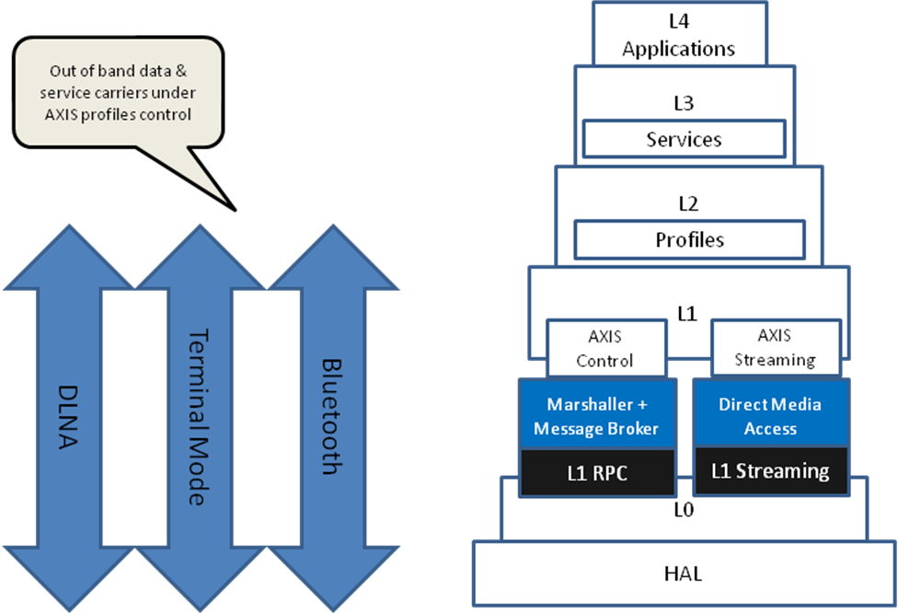
Figure 1: AXIS Framework

AXIS technology includes:
- Profile-oriented protocol performing control functions and data exchange
- In-band and out-of-band multimedia data exchange functionality
- Development toolchain

AXIS contains default data exchange channel. Data can be exchanged over any existing profile which satisfies the requirements for this kind of data transmission. Out of band carrier can be used when required. In this case AXIS profile transfers data via some standard profile, but at least one in-band AXIS control channel is used for service functionality.

Use-cases
AXIS primary use-case is to share content and functionality between in-car Headunit and external Smartphone or Tablet.

The following use-cases are covered by AXIS:
- Use telephony service with the Head Unit
- Share mobile device screen to the Head Unit
- Use mobile device to display from the Head Unit
- Share media content to the multiple vehicle and consumer devices
- Share internet access from mobile device
- Integrate navigation
- Integrate cameras
- Integrate aftermarket equipment
- Synchronize data between devices
- Access device’s functionality via API
- Apps support.

Features and Requirements
AXIS has the following characteristics:
- Can be used within the huge variety of Head Units.
- Ensures secure connection between Head Unit and Mobile device.
- Independence on physical connection between devices. Different connection types are supported.
- Extended SDK API. Additional functionality can be easily developed and deployed on targets.
- Support updates.

Supported platforms:
AXIS is the multiplatform easy-portable solution. Reference implementation is developed for Linux based Head Unit and Android based mobile device.

Connection between devices:
AXIS contains low-level abstraction layers L0 and HAL providing logical channel multiplexing and abstraction over physical serial channel which allows operating over any sort of a carrier providing reliable serial link, such as:
- Wi-Fi
- Bluetooth
- USB
- Other

Programming with AXIS technology
AXIS technology provides two abilities for developers: Application development and Profile development. The first ability is mainly oriented on the developers community, the second ability is for both Head Unit and mobile devices developers.

For both abilities AXIS is delivered as software development kit (SDK) which is described below.

Architecture Overview
AXIS technology implementation based on the layered architecture. It is represented at the Figure 2.
Each layer interacts only with nearest neighbor layer from above and below.
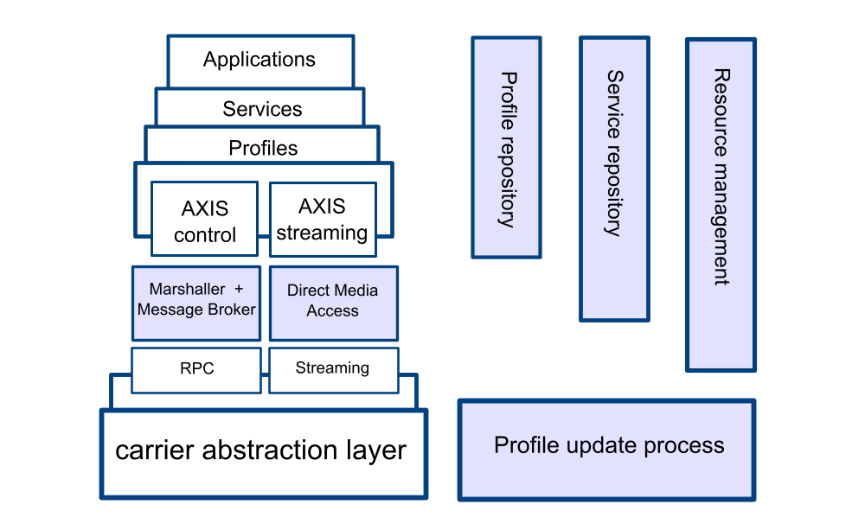

Figure 2: AXIS Architecture

Application layer (L4)
The application layer is the top layer of the AXIS architecture. Application is designed to perform a specific function directly for the user or, in some cases, for another application program. It implements business logic and HMI. Application is not involved into communication process. In AXIS architecture the application has access to the functionality provided by the service layer. Service and underlying layers provides all the communication support for the application layer. Application layer doesn’t define the application structure, design or functionality.
AXIS technology is distributed as SDK allowing for the developers to create their own apps and expand Head Unit and mobile device functionality with the features of the connected with AXIS technology device.
An AXIS application may have two roles: client or server. Depending on the role the application imports services (use services as a client) or exports services (provide services as a server).

Service layer (L3)
Service is the named list of profile API IDs that are dedicated to direct request from applications. The Service groups profile APIs into a single entity in the service repository to allow atomic initialization.
Set of profiles which can be used within the service is defined by the Head Unit OEM. Therefore OEMs can limit functionality of the application by specifying exact profiles able in frame of given service. There are also may be several profiles providing similar functionality and grouping profiles in service allows OEMs to choose exact profiles for a use-case specified by the service.

A service is implemented as an auto-generated by the SDK wrapper over used profiles and has its own API, which is consolidated from profile APIs. A service is linked with an application at compile time and contains the necessary code to support profile polymorphism. Profile polymorphism is implemented by using dynamic implementation selection that is loaded at run time.

Profile layer (L2)
Profile is a named and versioned set of modules (dynamic libraries) with a predefined API, responsible for remote method invocation and streaming content exchange.
Profile is the key feature of the AXIS technology. It implements single functionality and provides ability for two devices with same profiles to communicate.
Profile set defines capabilities of the device of AXIS technology usage.
Profiles providing same or similar functionality can be developed by different vendors and using different programming languages. To ensure profiles compatibility IDL is used. IDL describes low-level AXIS profile interface which describes interface to a lower-level.
Profile is responsible for control commands and data exchange between application and other party profile. Profile is also responsible for the security of the data transmission. The data exchange protocol is defined by the profile specification. In order to use AXIS technology, both devices must be compatible with the subset of AXIS profiles necessary to use the desired services.
Profile provides the following:
- Makes sure that the other party is identified and can be reached
- If appropriate, authenticates either the message sender or receiver or both
- Makes sure that necessary communication resources exist
- Ensures agreement at both ends about error recovery procedures, data integrity, and privacy
- Determines protocol and data syntax rules at the application level

From the implementation point of view profile consists of code and the manifest. The code is represented by the run-time loaded modules (one per client and server for each of supported architectures) with predefined function names. The manifest contains the profile API description.

Data transfer layer (L1)
Data transfer layer is responsible for data transferring between CAL and Profile layers. Data can be transferred in two ways: via remote procedure call (RPC) or via asynchronous data streaming.
The RPC is oriented on the data transfer control (AXIS control). Asynchronous data streaming is mostly applicable for media data transmission (AXIS streaming).
AXIS Supports 2 ways of data transmission:
- Control data. RPC mechanism is used to perform control data transmission
- Async. streaming data transmission

In case of out-of-band data transmission at least 1 control channel should be set to establish connection and initial intercommunication between 2 AXIS-enabled devices.

Carrier abstraction layer (L0)
The lowest layer is the carrier abstraction layer (CAL). The CAL component may use any physical connection between AXIS-enabled devices, e.g. wired Ethernet, Wi-Fi, Bluetooth, USB or almost any serial bus interface. CAL is a low-level API abstraction that enables AXIS over any sort of carrier that provides a reliable serial link.
CAL is responsible for physical connection management, including handshaking, exception processing, handover, and logical channel multiplexing. CAL operates with single serial connection that performs multiplexing of logical channels.
Every channel maintains its own scheduling rules for priority and exceptions. There are three types of channels with different schedulers: command, real-time, and critical. Data passed on critical channels is delivered with high priority. Real-time channels are suitable for passing multimedia data with minimal jitter, and real-time packets have internal timers so that the connection can be discarded in case of long delays.

AXIS SDK

Concept and characteristics

Concept
The AXIS software development kit AXIS SDK is intended for creating the high-level applications being executed on the Head Unit and on the mobile devices and to create the Profiles responsible for the abstraction over data exchange between two AXIS-enabled devices.

Operation
The AXIS SDK consists of the following components:
- Set of dynamically linked libraries
- Set of header files
- Toolchain for code generation

The toolchain contains two code generators: the axis_rpcgen and axis_lgen.

Axis_rpcgen is an IDL compiler that produces files in C language for a single IDL input.
Axis_lgen is a utility for service code generation with wrappers for the target language. Axis_lgen uses an XML-file with service description and profile API headers as an input to generate wrapper files with profile polymorphism implementation and target language binding (currently supported by Java).

Reference (API description)
API description, example of use, change log are available at the AXIS SDK Developer’s guide documentation.

OEM-Developed Components
OEMs can develop profiles that comply with their own security restrictions and stability requirements. OEMs can also develop applications (mainly on head unit side) according to their own requirements.

Community-Developed Components
Third parties may develop applications and optional profiles, but the head unit vendor may restrict the use of community-written profiles on their head unit products.

Programming Languages
An AXIS service provides a consistent API for contained profiles. An AXIS service implementation is generated automatically from the profile API and an XML description of the service. Currently, the supported languages are C, C++, and Java. Additional languages can be easily added by using FFI generators such as SWIG.

An AXIS service may be linked to an application statically (languages with static linking support such as C and C++) or dynamically (Java and scripting languages).

Approve History
Version | Approval Date | Issue ID | Approved By

References

[1] IETF, RFB 2119, Keys words for use in RFCs to Indicate Requirement Levels, March 1997. http://www.ietf.org/rfc/rfc2119.txt

Appendix A - Acronym List
API — application programming interface
CAL — carrier abstraction layer
DLNA — digital living network alliance
DSL — data structure language
FFI — foreign function interface
HMI — human machine interface
IDL — interface definition language
JNI — java native interface
LBG — Language Binding generator
PAD — packet assembler/disassembler
PUP — profile update process
RPC — remote procedure call
SDK — software development kit
SWIG — simplified wrapper and interface generator
VNC — virtual network computing

Appendix B - Glossary
Application pairing — process started at the time of registering all services by application. Including:
- Select appropriate profiles on both sides (service pairing phase 1)
- Select shadow applications on the server side
- Run shadow applications with loading shadow profiles
- Check consistency of loaded parts across network
- report process success or failure

Axis_gen — utility for code generation from the interface definition language (IDL)

Axis_lbgen — utility for generating language-dependent glue code for the language binding generator (LBG) service

Carrier — serial communications link for TCP/IP, Bluetooth, and USB

Carrier abstraction layer (CAL) — the part of the AXIS daemon responsible for low-level transmission over different carriers

Client-side — AXIS application operations performed by the client in a client-server relationship

Client-side application — AXIS application that runs on the client and can use many server instances that are loaded by multiple services

Control stream — abstract stream of data designed for RPC transmission that is used for typed, contracted data and signal delivery.

IDL-based interface — contract defined by IDL-file and used for restricted data transmission between profile pairs

IDL compiler — code generator used to create profile and PAD glue code

Interface definition language (IDL) — DSL designed for profile-to-profile remote call description, where the interface definition is specific to a given profile

Foreign Function Interface — interfaces designed for glue code written in different languages, for example the java native interface (JNI) is a foreign function interface

Handshaking — process of negotiation that dynamically sets the carrier parameters established between two devices before normal communication over the network begins

Language-binding generator — code generator used to create language-specific glue code between a service and the AXIS application

Logical channel — duplex transmission channel associated with a profile instance

Logical connection — all profile channels associated with given profile instance

Multimedia stream — binary stream of raw data with no types or entities recognizable on the AXIS infrastructure level and is used primarily to transfer large amounts of media data in real time

Physical pairing — process responsible for establishing the physical connection and handshaking

Profile — a named and versioned set of modules (dynamic libraries) with a predefined API, responsible for remote method invocation and streaming content exchange. The profile converts application-level operations into a form of API invocation of the process of formatted data exchange via RPC and PAD. Each profile has two role-specific implementations deployed on paired devices that are mutually connectable for data exchange according for the data exchange protocol (contract) defined by the given profile specification.

Profile API — is the named contract that specifies the methods whereby a requesting application receives typed data. The profile API contains method specifications and the definition of how these methods are to be used. Multiple profiles that implement the same API are polymorphs that can execute the same services on a selective basis.

Remote procedure call — method used to restrict profile interaction to only strong-typed messages and is also used to avoid finite automatons or protocol-based solutions

RPC level — automatically generated code based on interface specification (IDL)

RPCGEN — interface pre-compiler for Sun Microsystems RPC that is designed to generate C code from the IDL

Server-side —AXIS application loaded by AXIS daemon on the server in response to a client-side application

Server-side application — AXIS application performed by the server in a client-server relationship. A server-side application may implement one more services and can serve many client-side applications by dynamically creating or destroying service instances for client-side applications.

Service — is the named list of profile API IDs that are dedicated to direct request from applications. The Service groups profile APIs into a single entity in the service repository to allow atomic initialization

Service instance — a group of profiles that implement a given service

